Raw data on courses from different subject was reviewed and analysed and with this, I was able to track the performance of courses over time.

The analysis also helps us to understand where opportunities to increase revenue may lie.

Courses that have low turnout on subscribers was brought to light, reasons why it was so, were also highlighted and solutions to them.

Raw data on four different courses (Web development, Business finance, Musical instruments, and Graphic design) were merged together and duplicates were removed from the data. Blank cells were also removed. We also ensured that the headers were clear and concise. Web development subject was also replaced so as to have uniformity in the column.

Excel was one of the tool used for visualization, with excel, I was able to highlight the notable points in the data and it. Even when the data was edited, the charts created automatically updates, therefore, excel help in management of the data.

Tableau was also used for visualization, it helped to understand the data better and also I was also able to combine my charts suing dashboards in tableau, there was also measurement of filters, with tableau, we were also able to single out tables compare and understand their relationship. The table below shows the information of the top 20 most subscribed courses.

HERE ARE MY EXCEL VISUALIZATION AND TABLES

The table below shows the vlookup used, the vlookup was used to find the top 20 most subscribed courses and other information about them (subject, level ,ratings ,content duration, payment status)

|  |  |  |  |  |  |  |
| --- | --- | --- | --- | --- | --- | --- |
| **Num_subscribers** | **Subject** | **Level** | **Payment_status** | **Date** | **Ratings** | **Content_duration** |
| 268923 | Web Development | Beginner Level | Paid | 2013-02-14 | 0.82 | 10.5 |
| 161029 | Web Development | Expert Level | Paid | 2013-06-09 | 0.69 | 3.5 |
| 121584 | Web Development | Beginner Level | Not paid | 2015-11-02 | 0.89 | 43 |
| 120291 | Web Development | All Levels | Paid | 2014-04-08 | 0.78 | 3 |
| 114512 | Web Development | Beginner Level | Not paid | 2016-03-08 | 0.55 | 30.5 |
| 101154 | Musical Instruments | All Levels | Paid | 2012-06-15 | 0.88 | 4.5 |
| 98867 | Web Development | All Levels | Paid | 2015-04-13 | 0.82 | 3 |
| 84897 | Web Development | All Levels | Not paid | 2013-10-10 | 0.79 | 2 |
| 83737 | Web Development | Intermediate Level | Paid | 2014-07-19 | 0.85 | 6.5 |
| 79612 | Web Development | All Levels | Not paid | 2015-03-12 | 0.69 | 11.5 |
| 75499 | Musical Instruments | Beginner Level | Not paid | 2014-08-07 | 0.96 | 30 |
| 73783 | Web Development | Beginner Level | Not paid | 2016-02-11 | 0.9 | 22 |
| 73110 | Web Development | All Levels | Paid | 2012-07-27 | 0.94 | 2 |
| 72932 | Web Development | All Levels | Paid | 2013-09-25 | 0.39 | 1 |
| 70773 | Web Development | All Levels | Paid | 2015-03-19 | 0.57 | 6 |
| 69186 | Web Development | All Levels | Not paid | 2011-11-19 | 0.61 | 27.5 |
| 65576 | Business Finance | All Levels | Paid | 2013-04-20 | 0.56 | 8 |
| 64128 | Web Development | Beginner Level | Paid | 2014-11-22 | 0.96 | 1.5 |
| 59639 | Web Development | All Levels | Paid | 2013-12-09 | 0.55 | 4.5 |
| 59361 | Web Development | Beginner Level | Not paid | 2014-09-24 | 0.87 | 7 |

|  |  |
| --- | --- |
| **Row Labels** | **Sum of num_subscribers** |
| Business Finance | 1868711 |
| Graphic Design | 1063148 |
| Musical Instruments | 846689 |
| Web Development | 7981935 |
| **Grand Total** | **11760483** |

|  |  |
| --- | --- |
| **Row Labels** | **Average of num_subscribers** |
| Business Finance | 1569.026868 |
| Graphic Design | 1766.026578 |
| Musical Instruments | 1245.130882 |
| Web Development | 6635.024938 |
| **Grand Total** | **3199.260881** |

|  |  |
| --- | --- |
| **Row Labels** | **Average of price** |
| Business Finance | 68.69437448 |
| Graphic Design | 57.89036545 |
| Musical Instruments | 49.55882353 |
| Web Development | 77.03657523 |
| **Grand Total** | **66.11534276** |

|  |  |
| --- | --- |
| **Row Labels** | **Average of content_duration** |
| Business Finance | 3.557696613 |
| Graphic Design | 3.585465116 |
| Musical Instruments | 2.854387255 |
| Web Development | 5.586658354 |
| **Grand Total** | **4.096137106** |

|  |  |  |  |  |  |
| --- | --- | --- | --- | --- | --- |
| **Average of Rating** | **Column Labels** |  |  |  |  |
| **Row Labels** | **All Levels** | **Beginner Level** | **Expert Level** | **Intermediate Level** | **Grand Total** |
| Business Finance | 0.691516588 | 0.686215539 | 0.7 | 0.695373134 | 0.690352645 |
| Graphic Design | 0.730985075 | 0.727065217 | 0.884285714 | 0.721578947 | 0.73038206 |
| Musical Instruments | 0.312037037 | 0.313834586 | 0.296666667 | 0.281025641 | 0.308911765 |
| Web Development | 0.645466035 | 0.635379147 | 0.498571429 | 0.670895522 | 0.643050707 |
| **Grand Total** | **0.619371429** | **0.597317073** | **0.590172414** | **0.615734597** | **0.610867791** |

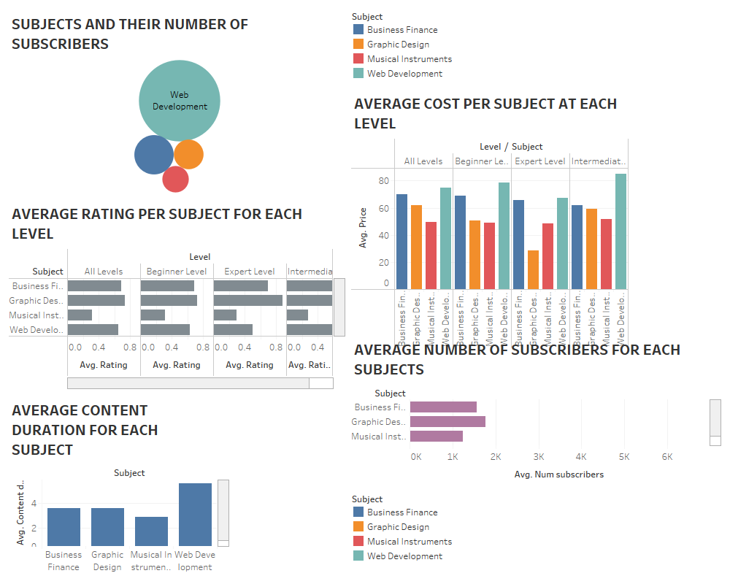

The visualization above was done using Tableau.

**FINDINGS**

From the analysis carried out, the graphical representation helped to know that web development had the highest turnout for the number of subscribers, as well as the ratings reviews. Also business finance also has a high turnout for number of subscribers and also reviews, but there has been a low rating for musical instruments, which could have been caused by the low content duration which has lead to the low turnout for the number of subscribers.

**SOLUTIONS**

Since subscribers rates web development well, there can be an increase in the cost of subject as well as improvement on the course to make it worth the increase in cost. Business finance can also get an increase in cost and better improvement in lecturers and their content duration.

Musical instruments should be looked into, by checking the reviews and seeing the problems that subscribers has for it and working on those comments. Subscribers that are currently in the course should be cajoled to rate the subjects well so as to encourage new subscribers to opt in. lecturers should also improve the content and probably input new techniques in teaching their students so as to get good ratings. There can also increase in the number of free subjects for musical instruments and graphic design so as to increase the number of subscribers.